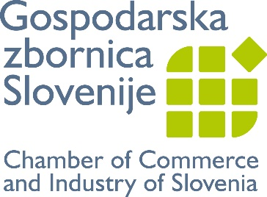

Our chamber’s business associations:

Association of Informatics and Telecommunications - ZIT
Chamber of Accounting Services
Chamber of Agricultural and Food Enterprises
Chamber of Construction and Building Materials Industry
Chamber of Media Providers
Chamber of Public Utilities
Chamber of Small business and Trade
Chemical Industries Association
Electronics and Electrical Industry Association
Energy Industry Chamber of Slovenia (EZS)
Engineering Association
Furniture and Wood Processing Association
Metal Processing Association – Members Catalogue
Metals and Non-metals Association
National Association of Consulting Engineers of Slovenia - NACES
Publishing and Bookselling
Real Estate Association
Slovene paper and paper converting Industry – Members Catalogue
Textiles, Clothing and Leather Processing Association
The Association of Chemical Industries of Slovenia - ACIS
Tourism and Hospitality Chamber of Slovenia
Transport Association

